Deliverable 3: User Manual
Lost and Found for Campus, Phase 1: Team Falcons, CSCE 5430, Fall 2026
Every screen shown in this manual is a faithful, pixel accurate recreation built directly from the project's real page components and stylesheet, reproducing the exact labels, fields, buttons, and messages the application uses. They were generated this way because a live, running instance was not reachable from the environment this manual was prepared in; they are not AI generated impressions of a hypothetical design.

1. Introduction
Lost and Found for Campus is a web application that lets students, faculty, and staff report lost or found items, search existing listings, and manage the listings they have posted themselves. This manual covers every Phase 1 feature: creating an account, verifying your email, signing in, resetting a forgotten password, browsing and searching listings, creating a Lost or Found listing with photos, and editing or removing your own listings.
This manual is written for the people who will use the application day to day. If you are looking for instructions on installing dependencies and running the project from source code, see the separate Compilation and Run Instructions document.

2. Accessing the Application
Open a supported web browser (current Chrome, Edge, Firefox, or Safari) on a desktop, laptop, tablet, or phone. No specialized hardware, plugin, or app installation is required.
During development and grading, the application runs locally. Your instructor or team will provide the address to open; by default this is http://localhost:5173 for the site itself. You do not need to know or type any backend or database address; the page you open talks to the server automatically.

3. Creating an Account
Select Register from the top navigation bar. You will need:
- Your first and last name.
- A campus email address ending in @unt.edu or @my.unt.edu. Any other email address is rejected with an on-screen message.
- A password of at least 8 characters.
After you submit the form, your account is created immediately, but it is not yet verified. The application automatically sends a verification email to the address you registered with.
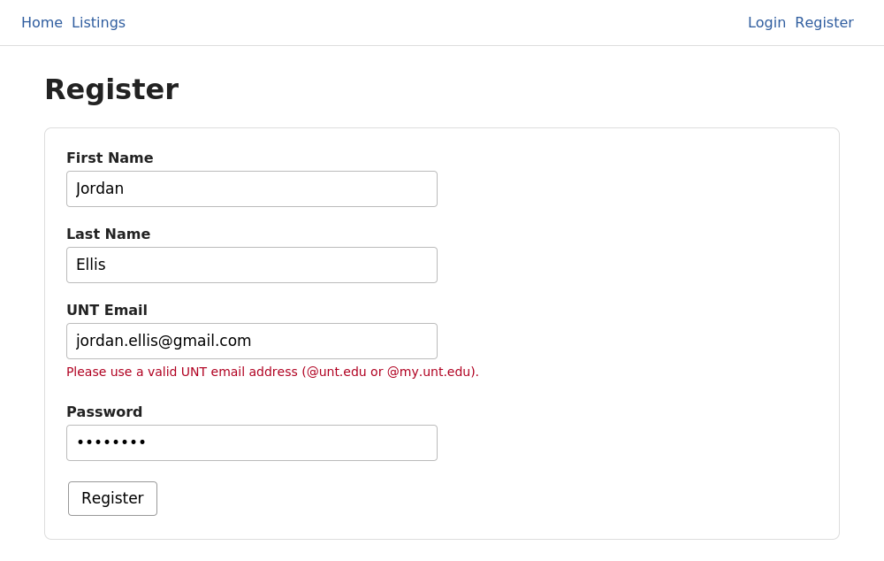
Figure 1. Register page, showing the inline error shown for a non campus email address.

4. Verifying Your Email
Open the verification email and select its link. The link is valid for 24 hours. Opening it completes verification immediately and shows a confirmation screen; you can then sign in.
You will not be able to create a listing until your email is verified. If you try beforehand, the application tells you so directly rather than failing silently.
If the link has expired or was already used, the screen tells you the link is invalid or expired. During development, if no email provider has been configured yet, the verification link is printed to the backend server's console instead of being emailed; ask whoever is running the server for the link in that case.
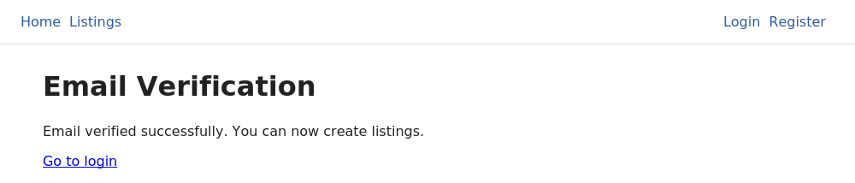
Figure 2. Email verification confirmation screen.

5. Signing In and Out
Select Login, enter your email and password, and submit. A successful sign in takes you to the Listings page. If your credentials are not recognized, the application shows a single, generic "Invalid email or password" message; it does not reveal whether the email or the password was the problem, which is a deliberate privacy protection.
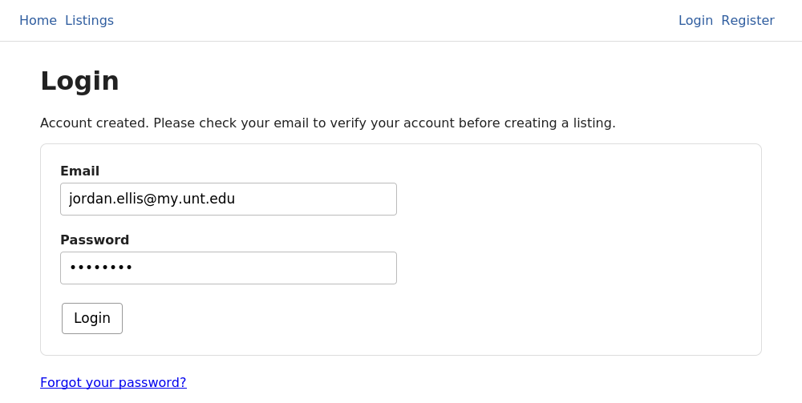
Figure 3. Login page, showing the confirmation notice carried over after registering.
Once signed in, the navigation bar shows a Create Listing link and a Logout button in place of Login and Register. Selecting Logout immediately signs you out on this device; you will need to sign in again to create, edit, or delete a listing.

6. Resetting a Forgotten Password
If you cannot remember your password, select Forgot your password? on the Login page, enter your email, and submit. For your privacy, the application shows the same confirmation message whether or not that email actually has an account; this prevents anyone from using this form to discover who is registered.
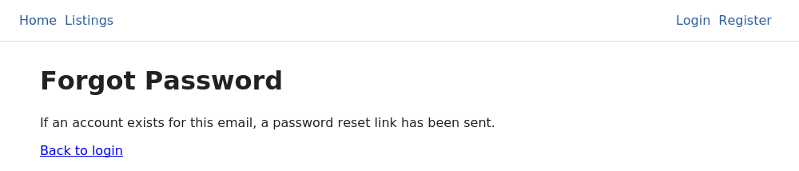
Figure 4. Forgot Password confirmation, shown identically regardless of whether the account exists.
If an account exists, a reset email is sent with a link valid for 1 hour. Opening it brings you to a page where you set a new password, at least 8 characters, entered twice to confirm it was typed correctly.
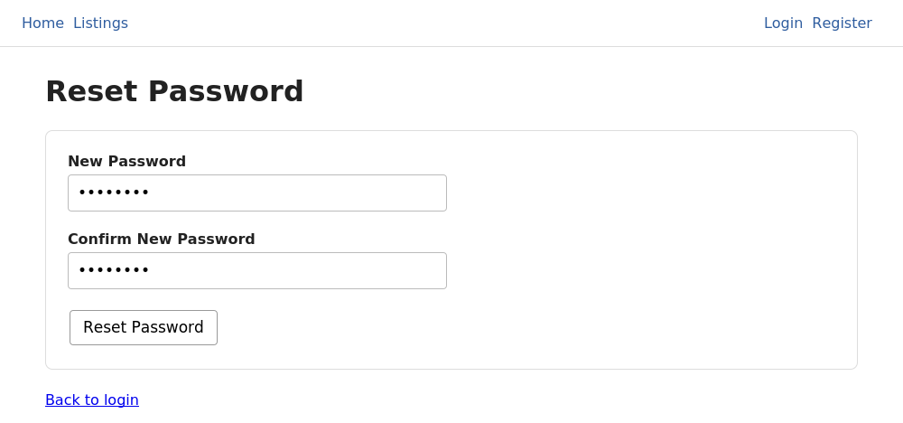
Figure 5. Reset Password page.

7. Browsing and Searching Listings
Select Listings from the navigation bar. You do not need to sign in to browse or search; this page is open to any visitor. Only Active listings (ones that have not been resolved or removed by their owner) are shown.
You can combine any of the following at once:
- Search: matches your keywords against each listing's title, description, and category.
- Type: Lost or Found.
- Category: for example Bags, Electronics, Keys.
- Building and Zone: the campus location where the item was lost or found.
- Date From / Date To: restricts results to a date range.
Results are shown 20 at a time, with Previous and Next controls at the bottom of the page. Selecting Clear resets every filter and returns to the first page.
If you are signed in and a listing is one you posted yourself, Edit and Delete buttons appear directly on that listing's card; they do not appear on listings posted by other people.
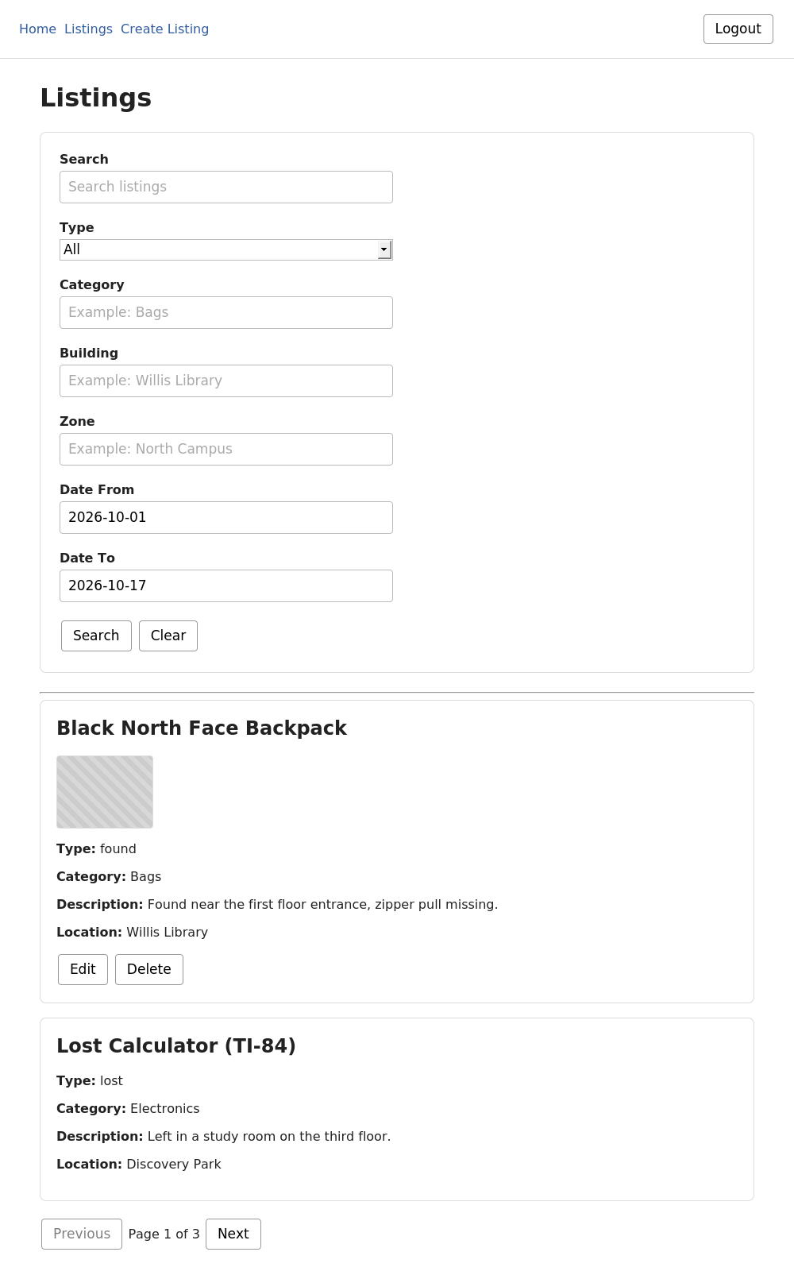
Figure 6. Listings page with search and filter controls, a listing with photos, and pagination.

8. Creating a Lost or Found Listing
You must be signed in and have a verified email to create a listing. Select Create Listing and complete the form:
1. Type: choose Lost or Found.
2. Title, Category, Description, and Date: all required.
3. Building: required. Zone is optional and narrows the location further.
4. Photos: choose up to 3 image files (JPEG, PNG, or WebP, 5 MB or smaller each). A Found listing requires at least one photo; a photo is optional for a Lost listing, since you may not have one of an item you lost.
5. Private Identifying Details: optional, for Found listings. Describe something only the true owner would know (an engraving, a sticker, contents of a bag). This is never shown on the public listing, in search results, or to anyone other than you; it exists so you can verify a claimant's identity later.
Submitting the form with a required field missing does not clear anything you already entered; the specific missing or invalid field is identified on screen so you can fix just that one field.
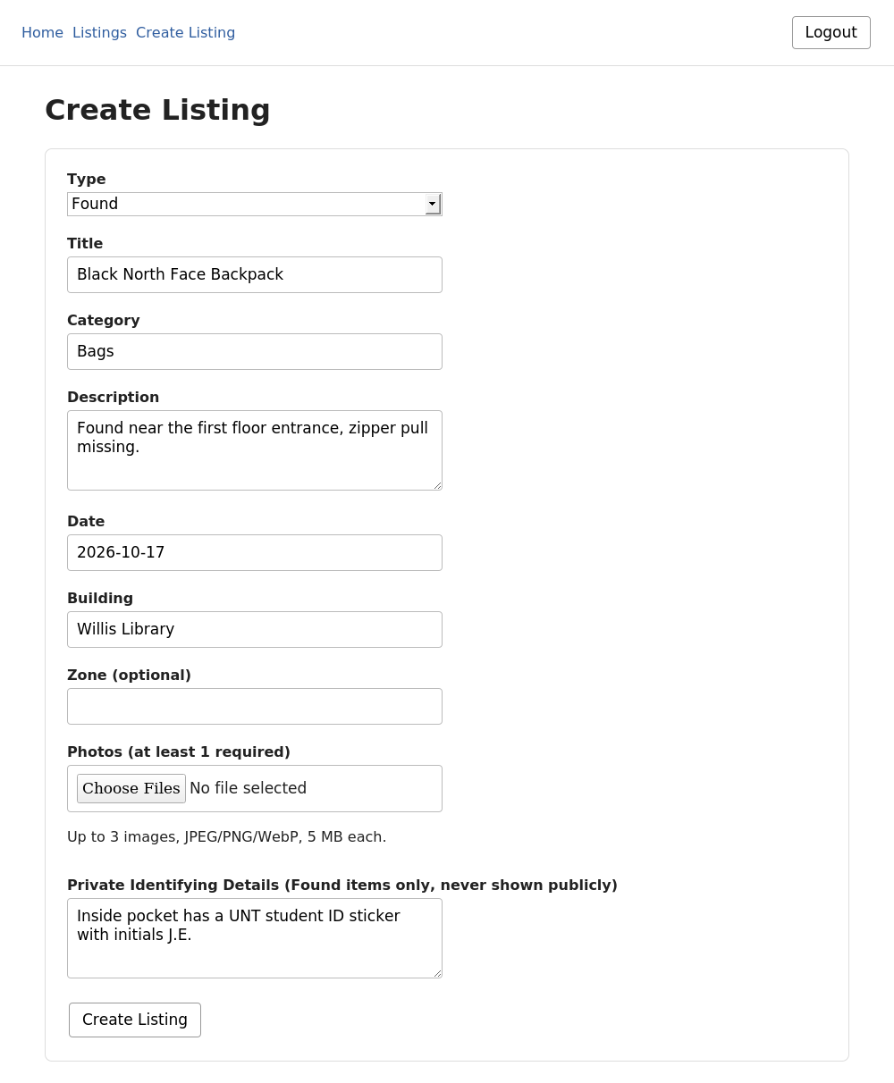
Figure 7. Create Listing page, shown with Found selected and its image requirement.

9. Editing Your Own Listing
From the Listings page, select Edit on any listing you posted. The form opens pre-filled with that listing's current information. Change whatever you need and select Save Changes.
Photos are optional on this form: leave the photo field empty to keep the listing's existing photos exactly as they are, or choose new files to replace all of them at once.
Only the original poster can edit a listing. If you attempt to edit a listing you do not own (for example, by opening its edit link directly), the application rejects the request.
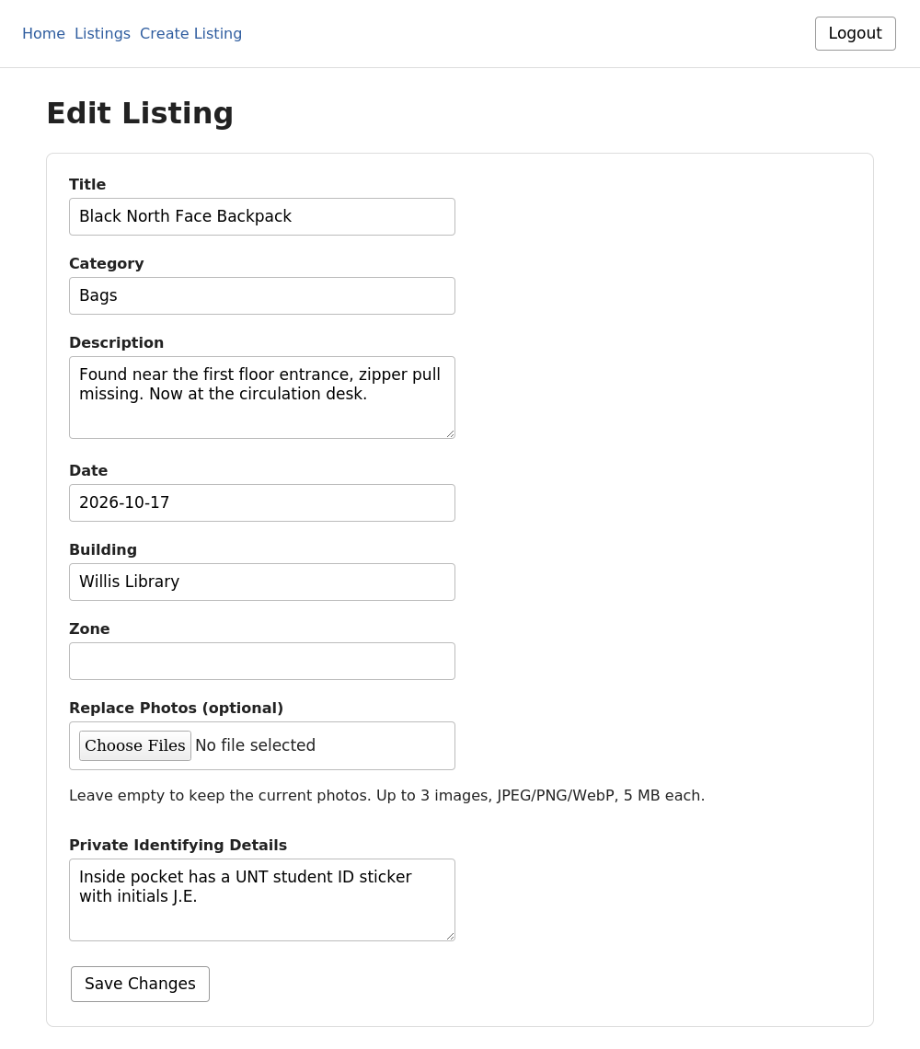
Figure 8. Edit Listing page, pre-filled with the listing's current details.

10. Removing Your Own Listing
Select Delete on a listing you posted. You will be asked to confirm before anything happens. Deleting a listing removes it from the public Listings page immediately; the record itself is kept rather than erased, consistent with how the course project is designed, but you will no longer see or be able to recover it from the application. As with editing, only the original poster can delete a listing.

11. Understanding On Screen Messages
The application is designed to tell you specifically what went wrong rather than failing silently. The table below lists every message you are likely to encounter in Phase 1 and what to do about it.
Situation | What You See | What To Do
A required field is left blank or invalid | The field is outlined and a specific message appears directly beneath it (for example, a UNT email address is required). | Correct the field indicated and submit again. Every other field you already filled in stays as you left it.
Registering with a non UNT email | "Please use a valid UNT email address." | Use an address ending in @unt.edu or @my.unt.edu.
Signing in with the wrong email or password | "Invalid email or password." | Re-enter your credentials, or use Forgot your password? if you are not sure.
Creating a listing before verifying your email | "Please verify your email before creating a listing." | Check your inbox (or the development console, during testing) for the verification email and follow its link, then try again.
Opening a verification or password reset link after it expired | "This verification link is invalid or has expired." / "This password reset link is invalid or has expired." | Request a new link (register again is not required for verification; use Forgot your password? for a reset link).
Editing or deleting a listing you do not own | "You can only edit your own listings." / "You can only delete your own listings." | Only the original poster can change or remove a listing. This is enforced by the system regardless of what the screen shows.
Uploading more than 3 images, a file that is not JPEG/PNG/WebP, or a file over 5 MB | "A listing can include at most 3 images." / "Each image must be no more than 5 MB." / a file type message. | Remove the extra or oversized file and select again.

12. Frequently Asked Questions
Why can't I create a listing right after registering?
Your email must be verified first. Check your inbox for the verification email and follow its link.
Can I see other people's private details on a Found item?
No. Private identifying details are visible only to the person who posted the listing. They are never included in public listings, search results, or anyone else's view.
Can someone else edit or delete my listing?
No. Only the account that created a listing can edit or delete it, regardless of what any screen shows.
What happens if I lose my password and never requested a reset?
Use Forgot your password? on the Login page at any time; it works even if you never used it before.
How many photos can I attach, and in what format?
Up to 3 photos per listing, each a JPEG, PNG, or WebP file no larger than 5 MB.

13. Quick Reference: Typical Workflow
1. Register with a campus email address.
2. Verify your email from the link sent to you.
3. Sign in.
4. Browse or search for an item.
5. If it is not already listed, create a Lost or Found listing.
6. Edit or delete your own listing as its status changes.
7. Sign out when finished.

